Module (Bootstrap Basic & Advanced) – 6

Q-1) What are the advantages of Bootstrap?

Ans-1) Bootstrap is a powerful, feature & packed frontend toolkit, build anything from porotype to production –in minutes.

1)Easy to initiation 2)Responsiveness 3)Highly customizable 4)Update at the doorstep

Q-2) What is a Bootstrap Container, and how does it work?

Ans-2) In Bootstrap, container is used to set the content's margins dealing with the responsive behaviors of your layout. It contains the row elements and the row elements are the container of columns (known as grid system).

The container class is used to create boxed content.

There are two container classes in Bootstrap:

1. container
2. container-fluid

* The .container class provides a responsive fixed width container
* The .container-fluid class provides a full width container, spanning the entire width of the viewport

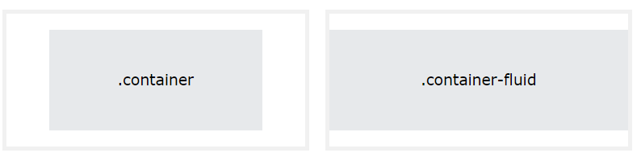

Q-3) What are the default Bootstrap text settings?

Ans-3)

* Font Family: Bootstrap uses the system's default font stack, usually consisting of a combination of sans-serif fonts such as Arial, Helvetica, and sans-serif.
* Font Size: The default font size for the body text is 16 pixels (1rem), with relative sizing for other elements. Headings (h1 to h6) have varying font sizes from larger to smaller.
* Text Alignment: Text is aligned left (text-left), center (text-center), right (text-right), or justified (text-justify) based on the CSS class applied.

Q-4) What do you know about the Bootstrap Grid System?

Ans-4) Bootstrap's grid system uses a series of containers, rows, and columns to layout and align content. It's built with flexbox and is fully responsive.

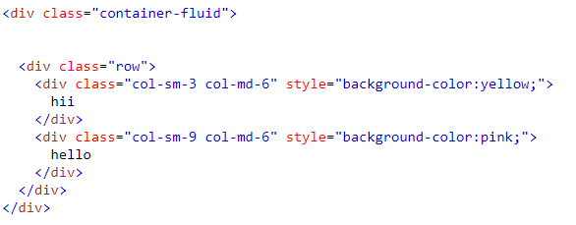

Output:



Q-5) What is the difference between Bootstrap 4 and Bootstrap 5?

Ans-5) Difference between Bootstrap 4 and Bootstrap 5

| **BASIS OF** | **BOOTSTRAP 4** | **BOOTSTRAP 5** |
| --- | --- | --- |
| **Grid System** | It has 5 tier (xs, sm, md, lg, xl). | It has 6 tier (xs, sm, md, lg, xl, xxl). |
| **Color** | It has limited colors. | Extra colors added with the looks, A card improved color palette. there are various shades available to choose. |
| **Jquery** | It has jquery and all related plugins. | Jquery is removed and switched to vanilla JS with some working plugins |
| **Internet Explorer** | Bootstrap 4 supports both IE 10 and 11. | Bootstrap 5 doesn’t support IE 10 and 11. |
| **Form elements** | Radio buttons, checkboxes have different look in different OS and browsers. The form uses whatever default browsers provide. | The look of form elements will not change, on different OS or browser. The forms can be customized and form controls can be added, they would not depend on browser. |
| **Utilities API** | We cannot modify utilities in bootstrap 4 | Bootstrap 5 gave freedom to modify and also create our own utility |
| **Gutter** | We use .glutter with fontsize in px | We use .g* with fontsize in rem |

Q-6) What is a Button Group, and what is the class for a basic Button Group?

Ans-6) Button Groups” in Bootstrap is a class of name “btn-group” which is used to create a series of buttons in groups (without spaces) vertically or horizontally.

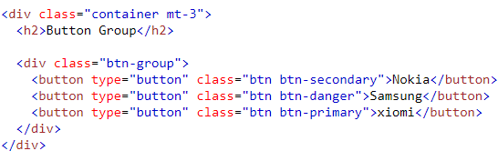

Output:

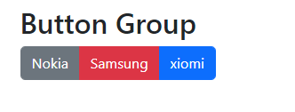

Q-7) How can you use Bootstrap to make thumbnails?

Ans-7)

* Add an <a> tag with the class of .thumbnail around an image.
* This adds four pixels of padding and a gray border.
* On hover, an animated glow outlines the image.

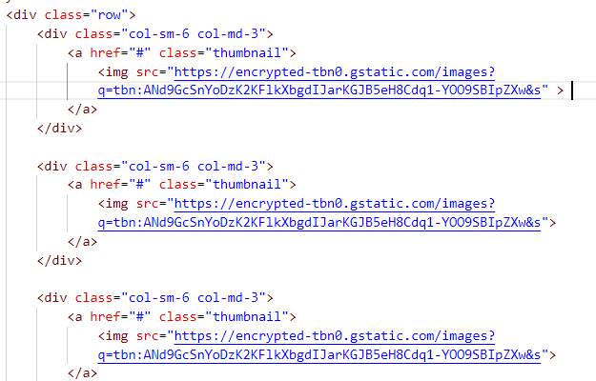

Output:



Q-8) In Bootstrap 4, what is flexbox?

Ans-8)Bootstrap 4 now uses flexbox, instead of floats, to handle the layout.

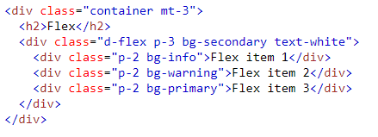

Output:



Q-9) How can one create an alert in Bootstrap?

Ans-9) Bootstrap Alerts are used to provide an easy way to create predefined alert messages. Alert adds a style to your messages to make it more appealing to the users.

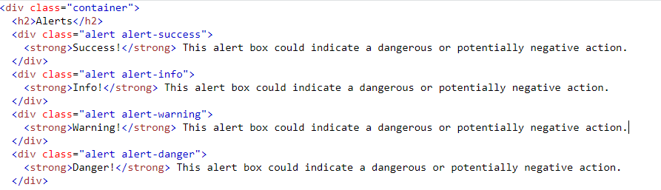

Output:

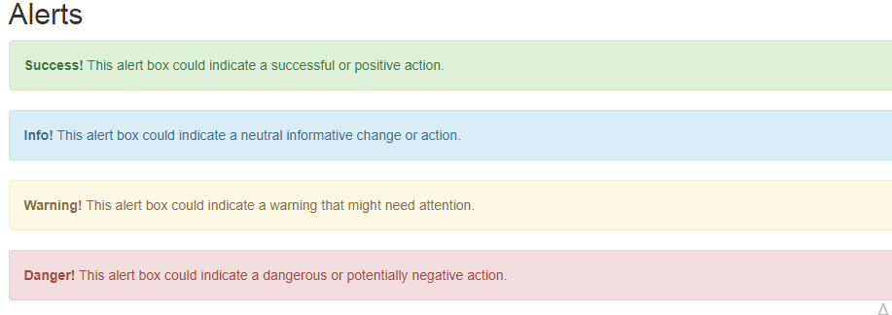

Q-10) What is a bootstrap card and how would you create one?

Ans-10) A basic Bootstrap card consists of a . card class with the . card-body class, allowing you to add text, images, links, and other Bootstrap elements within a rounded border.

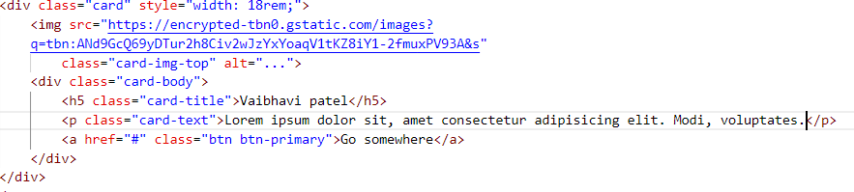

Output:

